**Module 4 – Mockito Hands-On Exercises**

**Exercise 1: Mocking and Stubbing**

Scenario: You need to test a service that depends on an external API. Use Mockito to mock the external API and stub its methods.

|  |  |
| --- | --- |
| **ADD DEPENDENCIES:**  <dependencies>  <dependency>  <groupId>org.junit.jupiter</groupId>  <artifactId>junit-jupiter-api</artifactId>  <version>5.10.0</version> <scope>test</scope>  </dependency>  <dependency>  <groupId>org.junit.jupiter</groupId>  <artifactId>junit-jupiter-engine</artifactId>  <version>5.10.0</version> <scope>test</scope>  </dependency>  <dependency>  <groupId>org.mockito</groupId>  <artifactId>mockito-core</artifactId>  <version>5.10.0</version> <scope>test</scope>  </dependency>  </dependencies> | **ADD BUILD PLUGINS:**  <build>  <plugins>  <plugin>  <groupId>org.apache.maven.plugins</groupId>  <artifactId>maven-compiler-plugin</artifactId>  <version>3.8.1</version> <configuration>  <source>1.8</source>  <target>1.8</target>  </configuration>  </plugin>  <plugin>  <groupId>org.apache.maven.plugins</groupId>  <artifactId>maven-surefire-plugin</artifactId>  <version>3.0.0-M5</version> <configuration>  <argLine>  --add-opens java.base/java.lang=ALL-UNNAMED  --add-opens java.base/java.util=ALL-UNNAMED  </argLine>  </configuration>  </plugin>  </plugins>  </build> |
| **ExternalApi.java**  package com.example  public interface ExternalApi {  String getData();} | **MyService.java:**  package com.example;  public class MyService {  private ExternalApi externalApi;  public MyService(ExternalApi externalApi) {  this.externalApi = externalApi;  }  public String fetchData() {  return externalApi.getData();  }  } |

**MYSERVICETEST.JAVA:**package com.example;

import static org.mockito.Mockito.*;

import org.junit.jupiter.api.Test;

import org.mockito.Mockito;

import static org.junit.jupiter.api.Assertions.assertEquals;

public class MyServiceTest {

@Test

public void testExternalApi() {

ExternalApi mockApi = Mockito.mock(ExternalApi.class);

when(mockApi.getData()).thenReturn("Mock Data");

MyService service = new MyService(mockApi);

String result = service.fetchData();

assertEquals("Mock Data", result);

verify(mockApi).getData();

}

}

**OUTPUT:**

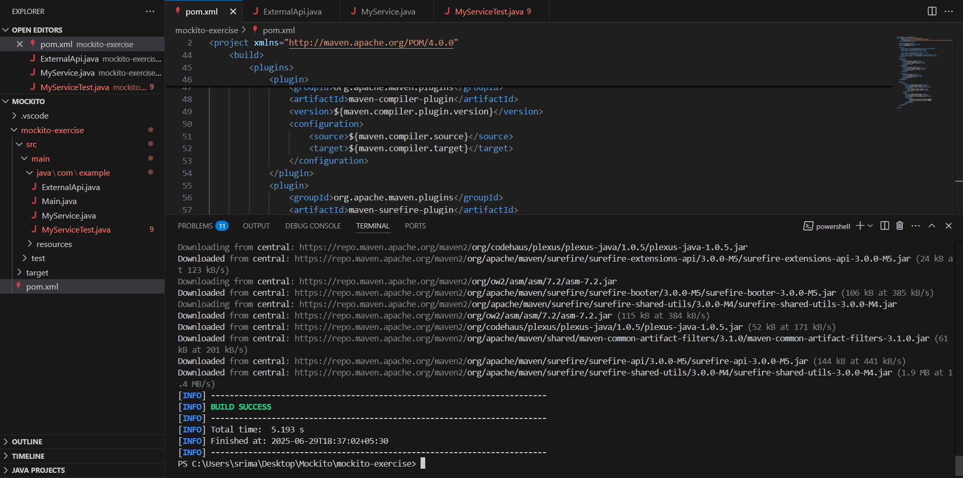

**Exercise 2: Verifying Interactions**

**Scenario:** You need to ensure that a method is called with specific arguments.

**testExternalApi():**

package com.example;

import static org.mockito.Mockito.*;

import org.junit.jupiter.api.Test;

import org.mockito.Mockito;

import static org.junit.jupiter.api.Assertions.assertEquals;

public class MyServiceTest {

@Test

public void testExternalApi() {

ExternalApi mockApi = Mockito.mock(ExternalApi.class);

when(mockApi.getData()).thenReturn("Mock Data");

MyService service = new MyService(mockApi);

String result = service.fetchData();

assertEquals("Mock Data", result);

verify(mockApi).getData();

}

@Test

public void testVerifyInteraction() {

ExternalApi mockApi = Mockito.mock(ExternalApi.class);

MyService service = new MyService(mockApi);

service.fetchData();

verify(mockApi).getData();

}

}

**OUTPUT:**

